SIMATS ENGINEERING

CSA15 – CLOUD COMPUTING AND BIG DATA ANALYTICS

ASSIGNMENT 3 – CO3
OBE-Based Evidence Principle

Design a Cloud-Based Collaborative Solution
CO3: Implement cloud-based solutions using cloud storage, web APIs, and platform services for real-world applications.

Field | Details | Field | Details
Student Name | V.Anish Reddy | Register Number | 192572055
Department / Section | CSE(AI) | Academic Year / Semester | 2026
Faculty Name | R.Latha | Nature of Assignment | Individual
Duration | 1 Week | Total Marks | 50
Submission Date | 05-11-2026 | Evaluation Date | 05-11-2026

MARK SHEET (Rubric-based evaluation)
Task | Title | Max | Awarded | Evidence / evaluation focus
1 | Accessing Cloud Services through Different Methods | 6 |  | Access-method diagram; demonstration; screenshots; comparison
2 | Cloud Platforms and Web Applications | 7 |  | Two platforms; interaction diagram; app demonstration; evaluation
3 | Web APIs for Cloud Access | 7 |  | API design; executable client; two requests; responses
4 | Cloud Security and Network Access | 7 |  | Secure-access architecture; threats; authentication; mitigations
5 | Collaboration Using Cloud-Based Services | 6 |  | Shared workspace; permissions; edits; contribution evidence
6 | Integrated Cloud Access and Collaboration Mini Investigation | 7 |  | Scenario; architecture; prototype; two user tests; evaluation
7 | Day-4 Design Challenge: Cloud-Based Collaborative Solution | 10 |  | Two independent proposals; comparison; joint design; validation; defence
 | TOTAL | 50 |  | Percentage:

OVERALL REMARKS

_______________  Student Signature | _______________  Faculty Signature | _______________  Program Director

MANDATORY SUBMISSION EVIDENCE CHECK

✓ = Present in documented answer; P = Partly present; ✗ = Missing / not satisfied
Task | Evidence expected | Status | Evaluator note
1 | Three access methods, client–network–cloud diagram, demonstration and observations |  | Access-method classification and practical access screenshots to be checked.
2 | Two-platform comparison, interaction diagram and cloud web-app demonstration |  | Platform mapping, user-action sequence and local-versus-cloud evaluation to be checked.
3 | API flow, program, two request inputs, responses and execution evidence |  | Code, actual request/response outputs and analysis to be checked.
4 | Secure-access flow, four security considerations, threat and mitigation analysis |  | Authentication, authorization and secure-communication evidence to be checked.
5 | Shared workspace, permission settings, two collaborative activities and contributions |  | Verify shared editing, user roles, permissions and contribution screenshots.
6 | Integrated scenario, architecture, prototype, two user scenarios and results |  | Verify cloud access, collaboration workflow, tests and limitations.
7 | Two initial proposals, comparison record, joint design, tests and cross-defence |  | Verify independent proposals, joint decisions, observed results and both students’ understanding.

IMPLEMENTATION EVIDENCE CHAIN
Evidence item | Status | Observation
Cloud access methods |  | Browser, mobile and API access methods explained.
Cloud platforms |  | Two cloud platforms and their applications compared.
Cloud access demonstration |  | Actual screenshots need verification.
Web API implementation |  | Program and execution outputs need verification.
Cloud security |  | Authentication, authorization and security measures explained.
Cloud collaboration |  | Shared workspace and editing evidence need verification.
Mini-project |  | Design included; practical testing needs verification.
Day-4 design challenge |  | Individual proposals, joint design and validation need verification.
Student contributions |  | Contributions of both students need confirmation.
Screenshots |  | Original execution screenshots required.

SUBMISSION CHECKLIST (Not Separately Marked)
Requirement | Status
All 7 questions answered | ☐ Yes ☐ Partly ☐ No
Cloud access methods explained | ☐ Yes ☐ Partly ☐ No
Cloud architecture diagrams included | ☐ Yes ☐ Partly ☐ No
Two cloud platforms compared | ☐ Yes ☐ Partly ☐ No
Web API program and testing completed | ☐ Yes ☐ Partly ☐ No
Cloud security explained | ☐ Yes ☐ Partly ☐ No
Cloud collaboration demonstrated | ☐ Yes ☐ Partly ☐ No
Mini-project completed and tested | ☐ Yes ☐ Partly ☐ No
Day-4 design challenge completed | ☐ Yes ☐ Partly ☐ No
Student A and B contributions recorded | ☐ Yes ☐ Partly ☐ No
Screenshots and practical evidence attached | ☐ Yes ☐ Partly ☐ No
Viva recommended | ☐ Yes ☐ No

CLOUD COMPUTING AND BIG DATA ANALYTICS
ASSIGNMENT 3 – CO3

CO3: Implement cloud-based solutions using cloud storage, web APIs, and platform services for real-world applications.

Mode: Pair Work – 2 Students per Group
Duration: 1 Week Total Marks: 50

OBE-Based Evidence Principle

The assignment requires students to demonstrate measurable evidence of:
Understand → Design → Implement → Demonstrate → Analyse → Evaluate
Both students must understand the complete assignment. Students should not simply divide questions between them. Individual responsibilities are assigned within each question so that the contribution and attainment of CO3 can be independently verified.

Q1 – Accessing Cloud Services through Different Methods 6 Marks
Shared Group Work
Together, the pair must:
- Identify different methods of accessing cloud services.
- Study browser-based/cloud console access.
- Study access through mobile applications.
- Study access through APIs.
- Identify the role of Internet/network connectivity.
- Select one suitable cloud service for demonstration.
Student A – Access Method Design
Student A must individually:
- Identify and classify at least three cloud access methods.
- Prepare a simple architecture/flow diagram showing:
Client → Network → Cloud Service
- Explain how a user accesses the selected cloud service.
- Identify the hardware/software requirements.
- Explain the role of the client and network.
- Justify which access method is most suitable for the selected application.
Student B – Practical Evidence
Student B must individually:
- Demonstrate access to a cloud service using one selected method.
- Record the steps/screenshots as evidence.
- Test the access using different devices or access methods where possible.
- Record observations such as accessibility, response, and usability.
- Identify one limitation encountered during access.
- Explain how the limitation can affect cloud usage.
Cross-Verification
Student A must be able to explain Student B's practical demonstration.
Student B must be able to explain Student A's access architecture.
Evidence Expected: Architecture diagram + screenshots/observations + comparison.

Q2 – Cloud Platforms and Web Applications 7 Marks
Shared Group Work
Together:
- Select two cloud platforms/services.
- Identify the web applications available through them.
- Study how users interact with the applications.
- Identify the cloud resources/services supporting the application.
- Prepare a comparative observation.
Student A – Platform Analysis
Student A must individually:
- Identify the major components of the selected cloud platform.
- Explain how the platform supports web applications.
- Map the user request to the cloud service.
- Explain the role of the Internet, server/cloud infrastructure and application.
- Prepare a simple interaction diagram.
Student B – Application Investigation
Student B must individually:
- Select one real-world cloud-based web application.
- Demonstrate its major functions.
- Record the sequence of user actions.
- Identify where cloud access is involved.
- Collect screenshots/evidence of the demonstration.
- Analyse the benefits of using the cloud-based application.
Joint Evaluation
Together answer:
If the same application were installed and operated only on a local computer, what limitations might users experience compared with accessing it through the cloud?
Evidence Expected: Platform/application mapping + demonstration evidence + evaluation.

Q3 – Web APIs for Cloud Access 7 Marks
Shared Group Work
Together:
- Study the concept of a Web API.
- Identify how APIs enable application-to-cloud communication.
- Select a simple publicly accessible API or cloud API.
- Develop a small program/client to send a request.
- Observe and record the response.
Student A – API Design and Understanding
Student A must individually:
- Explain the purpose of the selected API.
- Identify the request and response components.
- Represent the API communication using a flow diagram.
- Explain the role of:
  - Client
  - API request
  - Cloud/server
  - API response
- Explain how APIs enable programmatic cloud access.
Student B – Implementation and Evidence
Student B must individually:
- Implement a simple API request using Python or another suitable language.
- Execute the program.
- Record input/request and output/response.
- Test at least two different requests or inputs.
- Capture execution evidence.
- Analyse the observed results.
Joint Analysis
Together determine:
Why is API-based access useful when a large number of users/applications need to communicate with a cloud service automatically?
Evidence Expected: Program + execution screenshots + request/response evidence + analysis.

Q4 – Cloud Security and Network Access 7 Marks
Shared Group Work
Together:
- Identify security issues involved in accessing cloud services.
- Study authentication and authorization.
- Study secure network communication.
- Identify possible threats during cloud access.
- Prepare a secure cloud-access scenario.
Student B – Security Design
Student B must individually:
- Identify at least four security considerations for cloud access.
- Explain authentication and authorization.
- Explain the importance of secure communication.
- Design a secure access flow:
User → Authentication → Network → Cloud Service → Authorization → Resource
- Identify possible points of attack.
- Suggest suitable security measures.
Student A – Security Investigation
Student A must individually:
- Investigate a practical cloud-access security scenario.
- Demonstrate or document a suitable authentication mechanism where feasible.
- Compare secure and insecure access situations conceptually.
- Record observations.
- Explain how poor security practices can affect cloud users and data.
Joint Evaluation
Together answer:
If cloud access is available from anywhere through the Internet, what additional security measures are necessary compared with a local application?
Evidence Expected: Secure-access architecture + threat identification + mitigation analysis.

Q5 – Collaboration Using Cloud-Based Services 6 Marks
Shared Group Work
Together:
- Select a cloud collaboration platform/service.
- Create a shared document/folder/project space.
- Configure appropriate sharing permissions.
- Perform collaborative editing.
- Record the collaboration process.
Student A – Collaboration Design
Student A must individually:
- Identify the collaboration requirements.
- Design a suitable cloud collaboration workflow.
- Explain:
  - Sharing
  - Concurrent access
  - Version control
  - Permission management
- Identify the roles of different users.
- Justify the selected sharing permissions.
Student B – Collaborative Implementation
Student B must individually:
- Participate in the shared cloud workspace.
- Perform at least two collaborative activities.
- Record evidence of contribution.
- Demonstrate sharing/permission settings.
- Observe how changes made by users are reflected.
- Identify one collaboration issue and suggest a solution.
Cross-Understanding
Student B must explain:
How does cloud collaboration reduce the need to exchange multiple copies of the same file?
Student A must explain:
What problems can occur if incorrect sharing permissions are given?
Evidence Expected: Shared workspace + contribution evidence + permission screenshots + observations.

Q6 – Integrated Cloud Access and Collaboration Mini Investigation 7 Marks
Students must design a small real-world scenario that requires both cloud access and cloud collaboration.
Suggested Scenarios
Choose one:
- Cloud-based Student Project Management
- Online Student Attendance and Faculty Collaboration
- Cloud-Based Event Management
- Cloud-Based Assignment Submission and Evaluation
- Cloud-Based Hospital Appointment Coordination
- Cloud-Based Disaster Information Sharing
- Cloud-Based College Placement Coordination
Student A – System Design
Student A must individually:
- Define the problem.
- Identify users.
- Identify cloud access methods.
- Identify required cloud services.
- Design the system architecture.
- Explain how users access the system.
- Explain how users collaborate.
Student B – Evidence and Evaluation
Student B must individually:
- Develop a small prototype/mock-up/workflow where feasible.
- Demonstrate at least one cloud access mechanism.
- Demonstrate one collaboration mechanism.
- Record screenshots/evidence.
- Test the proposed solution using at least two user scenarios.
- Analyse the results.
- Identify limitations and possible improvements.
Joint Evaluation
Together answer:
How does combining cloud access and cloud collaboration improve the efficiency of the proposed system?

Q7 – DAY-4 DESIGN CHALLENGE

Design a Cloud-Based Collaborative Solution 10 Marks

This question must be solved collaboratively.

Neither student should independently prepare the complete solution and combine it later.

Stage 1 – Independent Design Proposal
Before discussing with each other:
Student A independently proposes:

- Problem definition
- Target users
- Cloud access method
- Required cloud services
- Collaboration mechanism
- Basic architecture
Student B independently proposes:

- Problem definition
- Target users
- Cloud access method
- Required cloud services
- Collaboration mechanism
- Basic architecture
Both initial proposals must be retained as evidence.

Stage 2 – Compare the Two Designs

Together discuss:
- Where the designs agree
- Where they differ
- Strengths and weaknesses
- Security concerns
- Accessibility
- Collaboration requirements
- Missing components
- Which ideas should be retained
Prepare a Design Comparison Record.

Stage 3 – Joint Final Design
Develop the final cloud-based solution.
The final design must identify:
- Problem
- Users
- Cloud access method
- Network requirements
- Cloud service/platform
- Web application/API requirement
- Collaboration mechanism
- Authentication/security
- Data/resource sharing
- Complete system workflow
Prepare an architecture such as:

Users → Client → Internet/Network → Cloud Platform → Application/API → Shared Resources

Stage 4 – Validation

Student A – Technical Validation

Student A must:
- Explain the selected cloud access method.
- Justify the platform/service selection.
- Explain the system architecture.
- Explain how API/web access is used, if applicable.
- Analyse the suitability of the design.

Student B – Experimental Validation

Student B must:
- Design test cases.
- Demonstrate the solution/workflow.
- Test different users/access conditions.
- Record observations.
- Present screenshots or other evidence.
- Compare expected and observed behaviour.

Stage 5 – Cross-Defence

Student A must explain:
What experimental evidence supports the group's cloud design?

Student B must explain:
Why was the selected cloud access and collaboration approach chosen?

Stage 6 – Joint Evaluation

Together determine:
- Benefits of the proposed cloud solution
- Access-related limitations
- Collaboration benefits
- Security risks
- Scalability considerations
- Possible improvements
- Situations where the proposed approach may not be appropriate
Final Question

What characteristics should a system designer consider before selecting cloud-based access and collaboration for a real-world application?

CONTRIBUTION RECORD

Each pair must include the following table at the end of the submission.
Question | Student A –  Primary Contribution | Student B –  Primary Contribution | Joint Work
Q1
Q2
Q3
Q4
Q5
Q6
Q7
The contribution record must reflect the actual work completed.
Primary contribution does not mean exclusive responsibility. Both students are accountable for the complete assignment.

INDIVIDUAL VERIFICATION – OBE EVIDENCE
Faculty may select any question or component for individual verification.
Each student must be able to:
- Explain the cloud access method.
- Explain the role of client, network and cloud service.
- Explain web application/API access.
- Explain security considerations.
- Demonstrate cloud collaboration.
- Interpret experimental evidence.
- Justify design decisions.
- Respond to a modified requirement or scenario.
A student should not answer:
“My partner did this section.”
Understanding of the complete submitted work is mandatory.

RECOMMENDED FACULTY VERIFICATION MODEL – VIVA
For each student, conduct a brief 4–5 minute verification.
Question 1 – Primary Responsibility
Ask one technical question from the component for which the student had primary responsibility.
Question 2 – Partner's Responsibility
Ask one question from a component primarily completed by the partner.
Question 3 – Transfer Question
Modify a condition and ask the student to reason about the consequence.
Examples:
“If Internet connectivity becomes unreliable, how would it affect cloud access?”
“If a shared cloud document is given editing permission to everyone, what problems could occur?”
“If the API becomes unavailable, how would your application behave?”
“If a user is authenticated but does not have permission to access a resource, what should happen?”
This provides individual evidence of CO3 attainment without requiring two completely separate assignments.

OBE Evidence Mapping
CO3 Component | Assignment Evidence
Build methods to access cloud | Q1, Q2, Q3
Access through platforms/web applications | Q2
Programmatic/API-based access | Q3
Secure cloud access | Q4
Collaboration within cloud | Q5
Apply cloud access + collaboration | Q6
Design and evaluate a cloud solution | Q7
Individual attainment | Viva + contribution record
Practical evidence | Screenshots, programs, observations, test results
Higher-order learning | Design, analysis, evaluation and transfer questions

Q1 – ACCESSING CLOUD SERVICES THROUGH DIFFERENT METHODS

CONCEPT AND ACCESS METHODS
Cloud computing makes computing resources available through a network. A user does not need to keep every application or file on one local computer. The user connects to a cloud service using a client device, a network connection and an access method supported by the service. The assignment requires the pair to study browser-based or cloud-console access, mobile application access and API access, and to identify the role of Internet connectivity.
1. Browser-based access
Browser-based access means opening a cloud service website through a web browser such as Chrome, Edge or Firefox. The user signs in, selects a service and performs operations through the website. The browser sends requests to the cloud server and displays the response. Example: a student opens Google Drive in Chrome, creates a folder and uploads an assignment.
2. Mobile application access
A mobile application is installed on a smartphone or tablet and connects to the cloud service through Wi-Fi or mobile data. It may support notifications, camera uploads, document scanning and offline access for selected files. Example: a student uses the Google Drive app to scan a handwritten page and upload it to a shared folder.
3. API-based access
An Application Programming Interface (API) allows one program to communicate with a cloud service. The program sends a request to an endpoint using an HTTP method such as GET or POST. The service processes the request and returns a response, often in JSON format. Example: a Python program requests a record from a test API and displays the returned data.
Client, network and cloud service
The client is the device or program that starts the request. The network transfers the request and response. The cloud service receives the request, checks identity and permission, performs the operation and returns the result. Without network connectivity, online access and synchronization may stop or become delayed.
Hardware and software requirements
- Hardware: laptop, desktop or smartphone with processor, memory and a network adapter.
- Software: operating system, supported browser or cloud mobile app; Python and an HTTP library when testing an API.
- Connectivity: Wi-Fi, Ethernet or mobile data. A stable connection improves file uploads and synchronization.
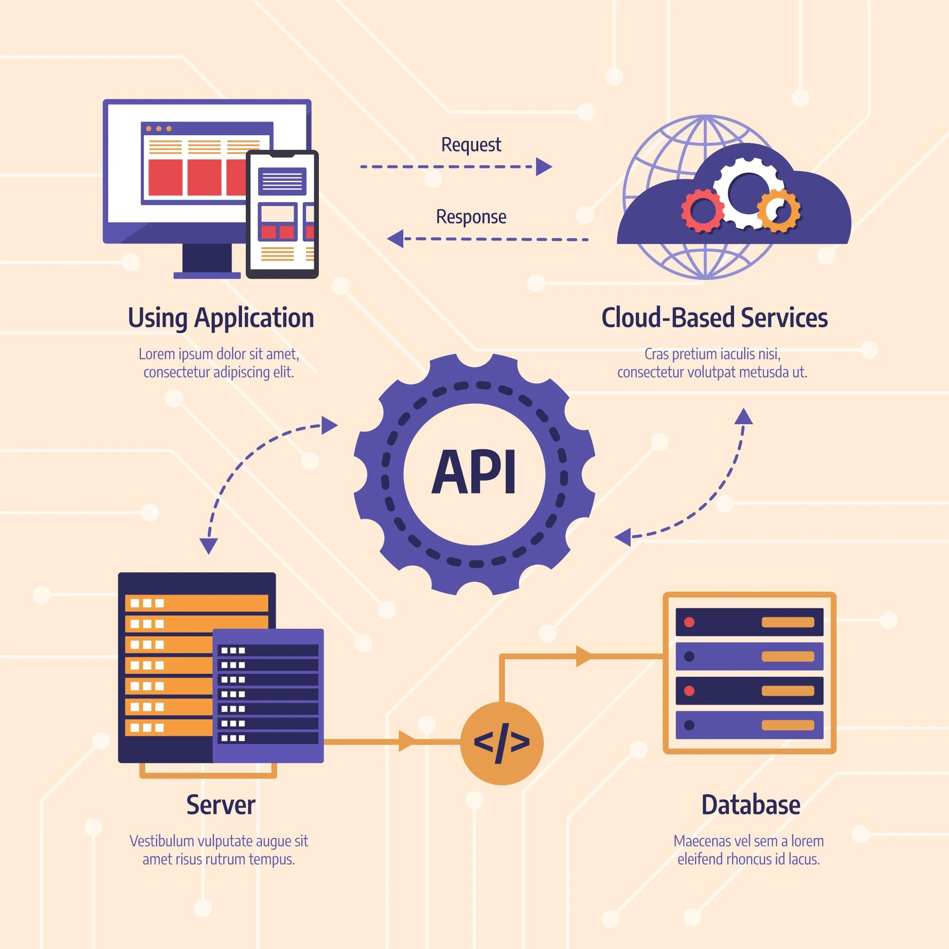
FLOWCHART IMAGE AND COMPARISON
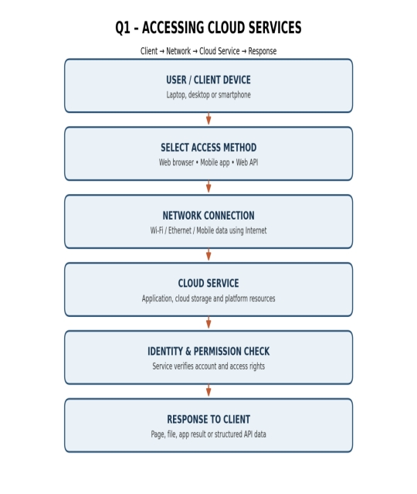
Figure 1: Cloud access architecture. The flowchart shows how a request travels from a client, through the network, to a cloud service and returns as a response.
Access method | How it works | Strength | Limitation
Web browser | User opens the service website and operates its interface. | Easy to use; no separate application installation is normally required. | Depends on browser compatibility and network access.
Mobile app | Installed app communicates with the cloud service. | Convenient on the move; can use camera and notifications. | Small screen; app updates and device compatibility matter.
Web API | Program sends HTTP requests to an endpoint. | Supports automation and application integration. | Requires programming, endpoint knowledge and suitable authentication.

Suitable method for the selected demonstration
For demonstrating cloud file storage to a student group, browser access is suitable because the user can create folders, upload files, open documents and manage sharing permissions on one screen. Mobile access is useful as a supporting method. API access is more suitable when a program must automatically exchange data with a service.
Access sequence
- Select a client device and confirm that the Internet connection is active.
- Open the cloud service using a browser or mobile app, or prepare an API client.
- Sign in or authenticate when required by the service.
- Select a resource and perform an operation such as upload, download or request data.
- The cloud service processes the request and sends a response.
- Check that the result is displayed or stored correctly.

PRACTICAL DEMONSTRATION AND EVALUATION

Practical demonstration: Google Drive browser access
- Connect the laptop to the Internet and open Google Chrome.
- Enter https://drive.google.com in the address bar.
- Sign in using an authorized account. Do not share the password with another person.
- Select New and create a folder named CO3 Cloud Access Demonstration.
- Open the folder and upload a sample PDF or document.
- Open the uploaded file and confirm that it is accessible.
- Use Share to add the partner's account and choose the correct role.
- Ask the partner to open the shared file and record the result.
Observation record
Observation item | What to record
Device and method | Laptop / smartphone; browser / app / API.
Connectivity | Wi-Fi / Ethernet / mobile data; whether connection was stable.
Accessibility | Whether sign-in and file access completed successfully.
Response and usability | Whether the file opened and the interface was easy to use.
Limitation | For example, slow upload on a weak network.
Effect of limitation | A slow connection delays uploads and may interrupt synchronization.

Student A and Student B responsibilities
Student A prepares the access-method classification, architecture and explanation of client, network and cloud service. Student B performs the practical access demonstration, records screenshots and observations, and identifies one limitation. Both students must be able to explain the other's work during cross-verification.
Evaluation
Browser, mobile and API methods serve different needs. Browser access is appropriate for a guided file-sharing demonstration, mobile access supports convenient access away from a computer, and APIs support programmatic operations. The method should be selected according to the users, device, task, network and security requirements.
Evidence to attach: original screenshots of the cloud service, created folder, uploaded file and sharing permission page. Record the actual device and observations. Do not insert fabricated screenshots.

Q2 – CLOUD PLATFORMS AND WEB APPLICATIONS

PLATFORM CONCEPTS
A cloud platform provides services for developing, hosting and operating applications through the Internet. Common resources include virtual machines or application hosting, object storage, databases, networking, identity management and monitoring. A web application uses these resources to provide functions to users through a browser or mobile interface.
Selected platform 1: Google Cloud Platform
Google Cloud Platform (GCP) provides computing, storage, database, networking and container services. Compute Engine provides virtual machines, Cloud Storage stores objects such as files and backups, Cloud SQL provides managed relational databases, and Google Kubernetes Engine supports containerized applications. Identity and Access Management controls permissions for cloud resources.
Selected platform 2: Microsoft Azure
Microsoft Azure provides services for hosting applications, storing data and managing cloud infrastructure. Azure Virtual Machines provide computing capacity, Blob Storage stores unstructured data, Azure SQL Database provides managed relational database services and Azure App Service hosts web applications. Role-based access control helps manage resource permissions.
How a platform supports a web application
The browser sends a request to the application over the network. The cloud platform routes the request to the application service. Application logic validates the request and reads or updates information in a database or storage service. The application then sends a response to the user's device. Identity and security services control access to the application and its data.
Example web application
Google Drive is a real-world cloud-based web application. Users sign in, create folders, upload files, preview documents and share them with other users. Google Docs, Sheets and Slides provide collaborative editing features. The application uses cloud-hosted services so authorized users can access their files from different devices.

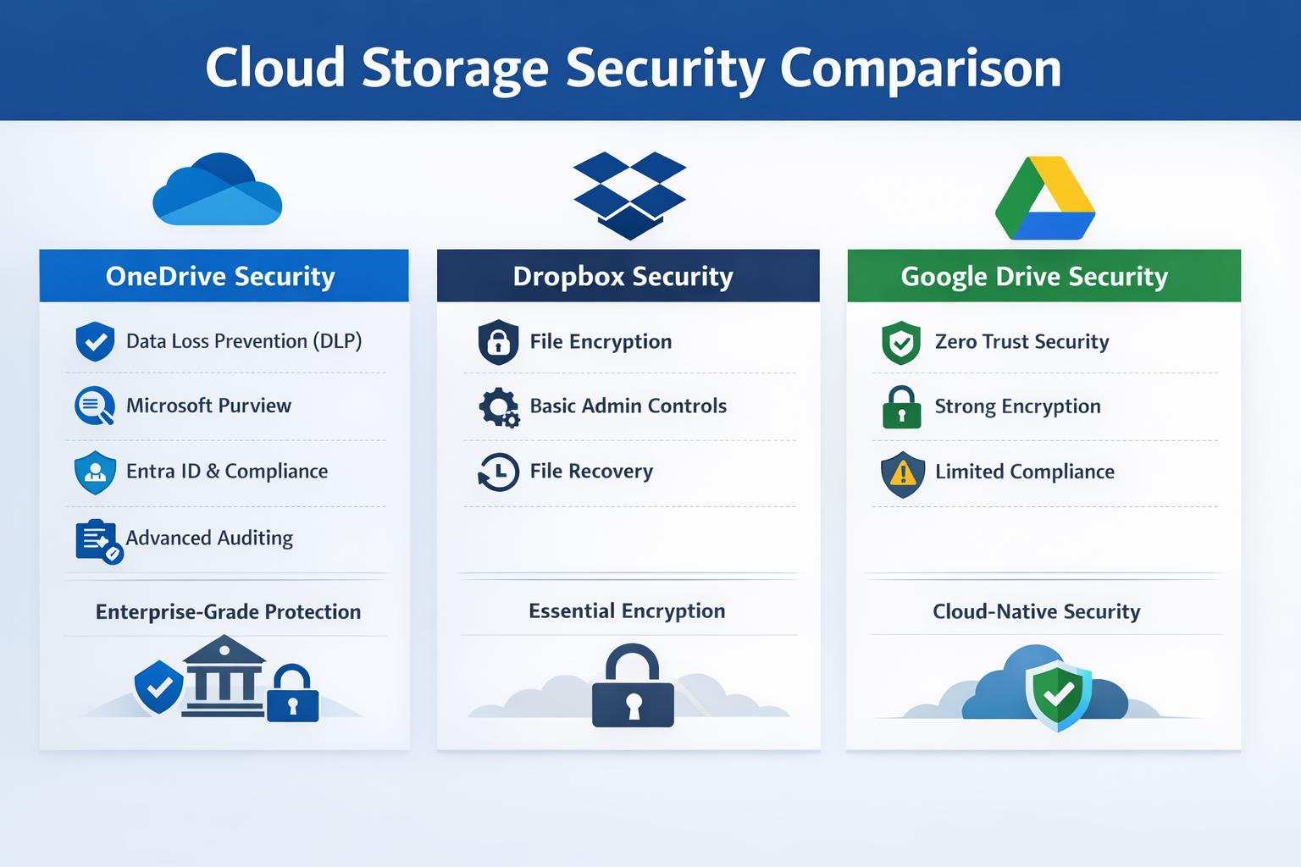
PLATFORM COMPARISON AND FLOWCHART
Feature | Google Cloud Platform | Microsoft Azure
Compute | Compute Engine; Cloud Run and other application services. | Virtual Machines; Azure App Service.
Object storage | Cloud Storage. | Azure Blob Storage.
Managed database | Cloud SQL and other database options. | Azure SQL Database and other database options.
Containers | Google Kubernetes Engine. | Azure Kubernetes Service.
Identity and permissions | Cloud IAM. | Microsoft Entra ID and Azure role-based access control.
Example use | Host an application and store uploaded documents. | Host an application and store uploaded documents.

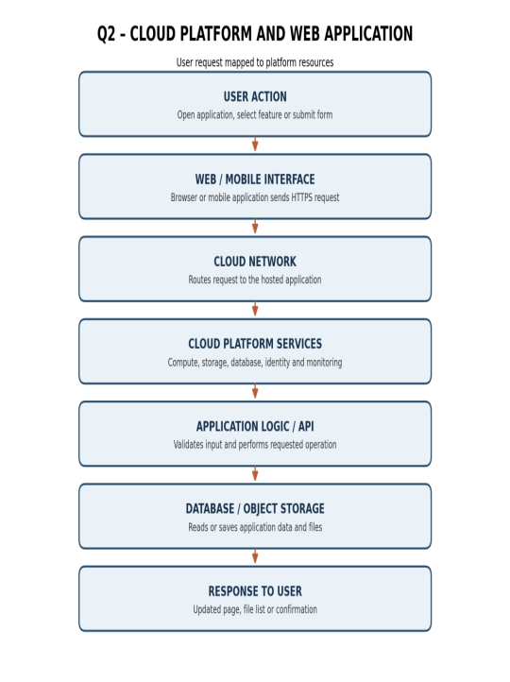
Figure 2: Application interaction flow. The user request is routed to cloud platform resources, processed by application logic and connected to the database or file storage.

User request mapping
User action | Cloud component involved | Result
Open the application | Web hosting / application service | Application page is displayed.
Sign in | Identity and authentication service | User identity is checked.
Upload a document | Application logic + object storage | File is stored in cloud storage.
Search or open a record | Application logic + database | Requested data is retrieved.
Share a file | Application permissions / identity service | Authorized users receive access.

APPLICATION DEMONSTRATION AND EVALUATION
Demonstration: major Google Drive functions
- Open Google Drive using a browser and sign in.
- Create a folder and give it a meaningful name.
- Upload a document and open it from the cloud workspace.
- Use the Share option to invite a partner.
- Select Viewer, Commenter or Editor according to the task.
- Ask the partner to open the file and verify the granted permission.
Cloud application versus local-only application
Cloud-based application | Application operated only on a local computer
Authorized users can access shared files from different devices. | Files may be limited to the computer unless transferred manually.
Multiple users can collaborate on a shared version where supported. | Collaboration may require sending copies between users.
The provider manages much of the underlying infrastructure. | The user or organization manages local installation, updates and backups.
Capacity may be scaled through cloud services, subject to cost and limits. | Capacity depends mainly on local hardware and configuration.

Joint evaluation
Cloud access improves accessibility and collaboration, but it depends on network connectivity, account availability and the provider's service. A local-only application may continue to work without the Internet and may offer greater direct control over local data, but sharing and remote access can require extra setup. The appropriate choice depends on the application and its users.
Student responsibilities and evidence
Student A identifies platform components, explains how a platform supports a web application and prepares the interaction diagram. Student B demonstrates a real-world web application, records user actions and captures evidence. Together, compare the selected platforms and evaluate the limitations of local-only operation.
Evidence to attach: platform dashboard or documentation view, application page, uploaded file and sharing demonstration. Add original screenshots and the actual observations made during the demonstration.

Q3 – WEB APIs FOR CLOUD ACCESS

API CONCEPT AND DESIGN
A Web API is an interface that allows software applications to communicate over a network using defined endpoints and request formats. A client program sends an HTTP request to an API server. The server processes the request and returns an HTTP response. APIs enable programmatic access because an application can request data or perform an operation without a person manually using a website.
Purpose of the selected API
This assignment uses JSONPlaceholder, a public fake REST API designed for testing and learning. The endpoint /posts/1 returns a sample post. The endpoint /posts/2 returns another sample post. It is suitable for demonstrating HTTP GET requests and JSON responses. It is a testing service, not a production database for storing real student information.
Request components
- Endpoint URL: identifies the resource, for example https://jsonplaceholder.typicode.com/posts/1.
- HTTP method: GET retrieves information; POST submits information; PUT or PATCH updates information; DELETE requests removal.
- Headers: provide metadata such as content type and authorization information where required.
- Request body: data sent with methods such as POST or PUT; a GET request normally does not need a body.
Response components
- HTTP status code: indicates the result, such as 200 for a successful request.
- Response headers: provide metadata about the response.
- Response body: contains the returned data, commonly JSON for a REST API.
- Error handling: the client should handle unsuccessful status codes, timeouts and invalid response data.
Role of the four main elements
The client creates and sends the request. The API request specifies the endpoint and method. The server receives and processes the request. The API response returns a status and data to the client, which parses and displays the result.
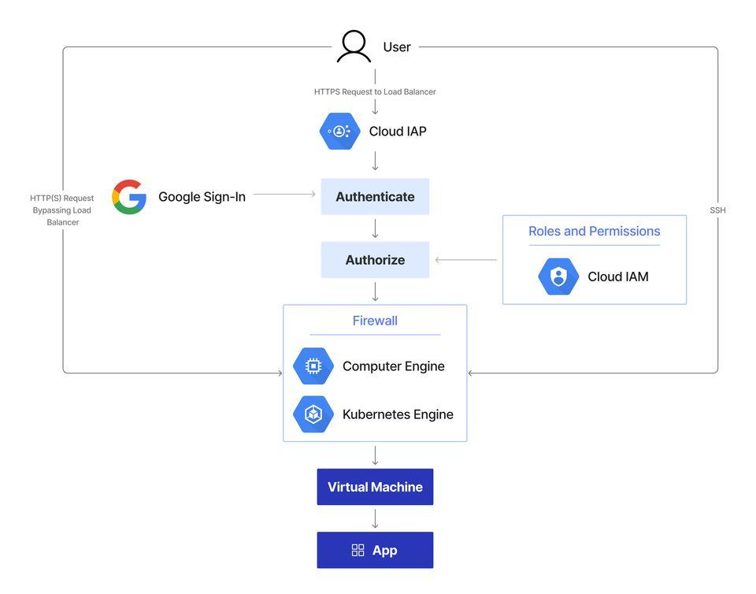
API FLOWCHART AND PROGRAM

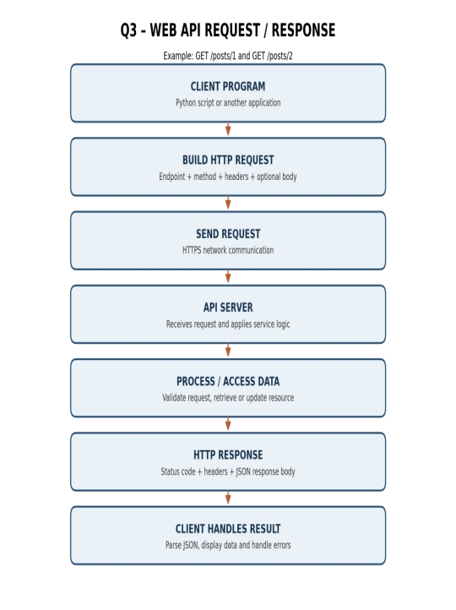
Figure 3: API communication flow from a Python client to an API server and back through an HTTP response.

Python program for two different requests
import requests
base_url = "https://jsonplaceholder.typicode.com/posts"
# Request 1: retrieve post number 1
response1 = requests.get(base_url + "/1", timeout=10)
print("Request 1 status:", response1.status_code)
print("Request 1 response:", response1.json())
# Request 2: retrieve post number 2
response2 = requests.get(base_url + "/2", timeout=10)
print("Request 2 status:", response2.status_code)
print("Request 2 response:", response2.json())
Install the required library once, if it is not already installed:
pip install requests
Program explanation
The program imports the requests library, stores the API endpoint, sends two GET requests to /1 and /2, and prints each HTTP status code and JSON response.
TESTING, RESULTS AND ANALYSIS
Two-request test record
Test | Input / request | Expected observation
1 | GET https://jsonplaceholder.typicode.com/posts/1 | Successful response normally returns HTTP 200 and a JSON object with userId, id, title and body.
2 | GET https://jsonplaceholder.typicode.com/posts/2 | Successful response normally returns HTTP 200 and a different JSON object with userId, id, title and body.

How to execute
- Open Python IDLE, VS Code or another Python environment.
- Install the requests package if necessary.
- Copy the program and save it as api_test.py.
- Run the program while connected to the Internet.
- Check both status codes and returned JSON objects.
- Capture a screenshot of the actual terminal output.
Analysis: usefulness for many users and applications
API-based access is useful when many users or applications need to communicate with a cloud service automatically. A common API interface allows programs to send requests in a consistent format. This reduces repetitive manual work and supports integration between systems. For example, a college portal could request student attendance data from a service and display it in its dashboard.
However, a production API must include suitable authentication, authorization, input validation, rate limiting, error handling and monitoring. A public testing endpoint should not be treated as a secure storage location for private data.
Student responsibilities and evidence
Student A explains the API purpose, endpoint, request and response components, and prepares the flow diagram. Student B implements and executes the program, tests two different requests and records the output. Both students analyse the results and explain programmatic cloud access.
Evidence to attach: screenshot of the executed Python program showing both requests, status codes and returned JSON. Record the date and environment used. The values shown by the API must come from the actual execution.

Q4 – CLOUD SECURITY AND NETWORK ACCESS

SECURITY CONCEPTS
Cloud security protects cloud accounts, applications, networks and stored information from unauthorized access, misuse, damage and data loss. Cloud services can be accessed through the Internet from different locations and devices. Therefore, security must cover user identity, permissions, network communication, devices and cloud resources.
Authentication
Authentication verifies the identity of a user or system. A common example is signing in with a username and password. Multi-factor authentication (MFA) adds another verification factor, such as an authenticator prompt or one-time code. Authentication answers the question: who is requesting access?
Authorization
Authorization decides what an authenticated user is permitted to do. Permissions should follow the principle of least privilege, meaning a user receives only the access needed for the assigned task. Example: a student may be allowed to view a shared file but not delete it.
Secure network communication
HTTPS uses Transport Layer Security (TLS) to protect communication between the client and the cloud service. It helps prevent unauthorized reading or modification of data while it travels across the network. Users should verify the website address and avoid entering credentials on suspicious pages.
At least four security considerations
- Strong authentication and MFA to reduce account takeover.
- Authorization and least-privilege permissions to limit access to resources.
- HTTPS/TLS and encryption to protect data in transit and at rest.
- Network controls such as firewalls, secure Wi-Fi and monitoring.
- Backups and tested recovery procedures to reduce data-loss impact.
- Software updates and device protection to reduce malware and known vulnerabilities.
SECURE FLOWCHART AND THREAT TABLE
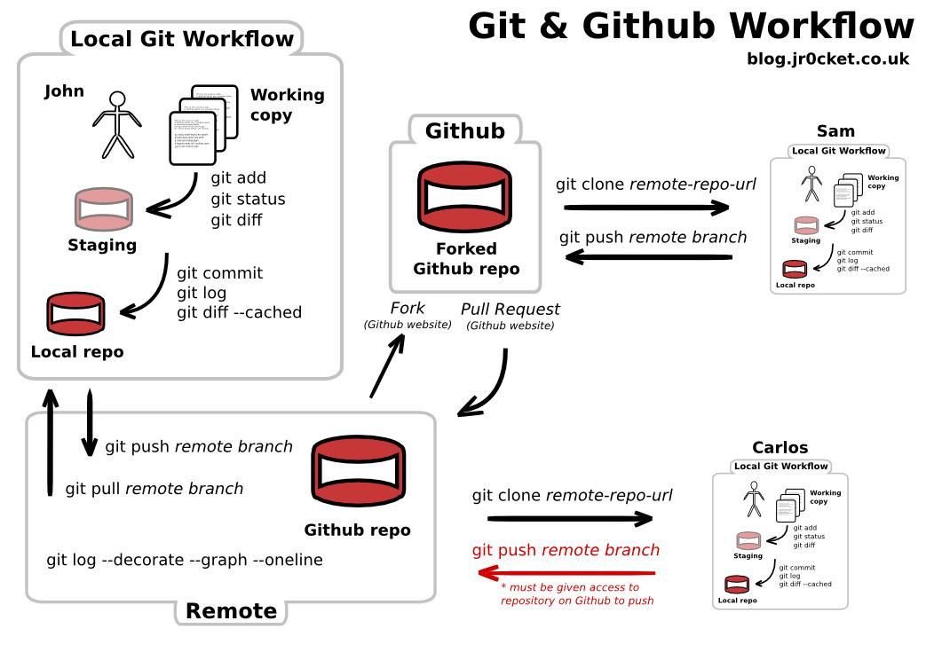
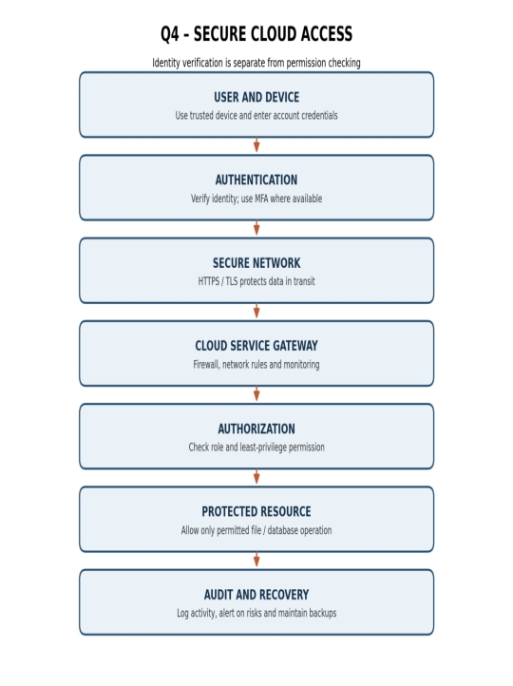
Figure 4: Secure cloud-access flow. Authentication verifies identity; authorization separately checks whether the user can access the requested resource.
Threat / attack point | Possible effect | Suitable mitigation
Phishing page | Credentials may be stolen. | Check the domain, avoid suspicious links and use MFA.
Weak or reused password | An attacker may gain account access. | Use a unique strong password and password manager.
Insecure network | Data may be exposed to interception or unsafe connections. | Use HTTPS/TLS and trusted networks.
Excessive sharing permission | Unwanted users may read, edit or delete files. | Apply least privilege and review sharing settings.
Compromised device | Stored credentials or files may be exposed. | Update software, lock devices and use security protection.
Data loss or accidental deletion | Important files may become unavailable. | Maintain backups and test recovery.

Secure versus insecure access
Secure access situation | Insecure access situation
Uses the correct website and HTTPS connection. | Uses an unknown link or ignores website warnings.
Uses MFA and a unique password. | Shares passwords or uses a weak password.
Gives Viewer access when editing is unnecessary. | Gives Editor or public access to everyone.
Reviews access and maintains backups. | Leaves old sharing links active and has no recovery copy.

PRACTICAL INVESTIGATION AND EVALUATION
Practical security scenario
Scenario: A student uploads an assignment to a cloud folder and shares it with a faculty member. The student must verify the correct account, use a secure connection and grant only the permission required. The faculty member should be able to review the file without receiving unnecessary control over the student's other folders.
Investigation steps
- Open the cloud service using its official website or application.
- Check the account security settings and enable MFA if available.
- Create or select a sample assignment file.
- Share it with the intended faculty or partner account.
- Select Viewer or Commenter when editing is not required.
- Review the access list and remove users who no longer need access.
- Record the observed settings without exposing passwords, one-time codes or private tokens.
Student responsibilities
Student B designs the secure access flow, identifies security considerations and proposes mitigations. Student A investigates a practical access scenario, documents an authentication mechanism where feasible and compares secure and insecure access. Both students explain how poor security can affect users and data.
Joint evaluation
Compared with a local application, Internet-accessible cloud services require stronger controls for remote identity verification, permission management, secure communication, account monitoring and data recovery. Access from anywhere increases convenience but also increases the number of devices and networks from which an account may be targeted.
Evidence to attach: original screenshots of MFA or account security settings, the sample file's sharing permissions and the final access list. Hide personal details and never include credentials. Record actual observations.

Q5 – COLLABORATION USING CLOUD-BASED SERVICES

COLLABORATION REQUIREMENTS
Cloud collaboration allows two or more users to work on shared files, documents or project spaces through the Internet. Instead of sending many copies of the same file, users access a shared cloud resource. The selected platform for this task is Google Drive with Google Docs.
Collaboration requirements
- A shared folder or project workspace that both users can access.
- User accounts for the owner and invited collaborators.
- Appropriate sharing permissions for each role.
- A shared document that supports editing and comments.
- A way to review changes or earlier versions.
- A contribution record showing what each student completed.
Sharing
Sharing gives another user access to a selected cloud resource. The owner chooses the intended person or group and assigns a permission. Sharing should be limited to people who need the resource.
Concurrent access
Concurrent access means multiple authorized users can open the same cloud document around the same time. In a collaborative editor, changes may appear to other users as the service synchronizes the document. Users should communicate before making major changes to the same section.
Version control
Version history records changes to a document over time. It helps users identify earlier content and, where supported, restore a previous version. It also supports accountability by showing the development of the shared work.
Permission management
Permission management controls whether a user can view, comment on or edit a resource. The owner should assign only the permission needed for the user's role and review access when the project ends.
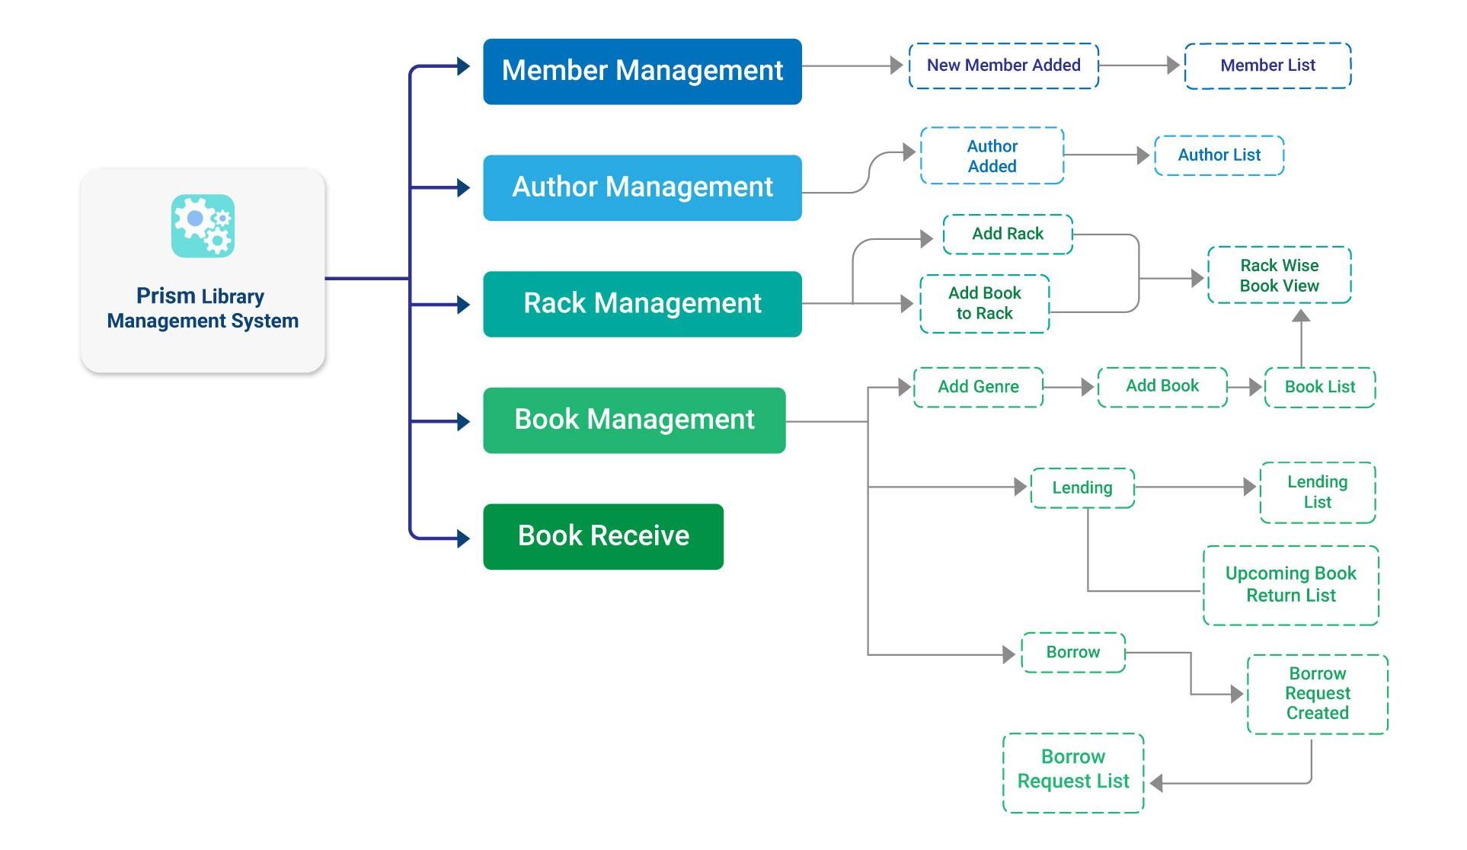
WORKFLOW IMAGE AND ROLE TABLE
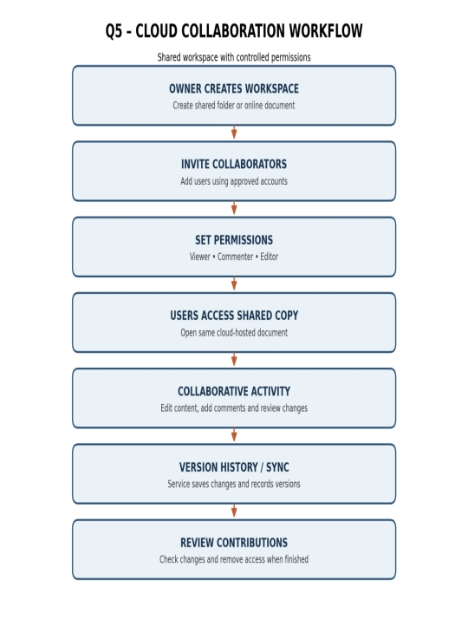
Figure 5: Shared workspace workflow, from workspace creation and invitations to editing, synchronization and review.
Role | Permission | Reason
Document owner / team leader | Owner or manager access | Creates the workspace and manages sharing.
Student A | Editor | Prepares and updates the assigned section.
Student B | Editor | Adds the second section and reviews shared content.
Faculty reviewer | Viewer or Commenter | Reads the work and provides feedback without unnecessary editing rights.

Two collaborative activities
- Shared editing: Student A creates a Google Doc and shares it with Student B as an Editor. Both students add their assigned sections to the same document.
- Comment and review: Student B selects a paragraph and adds a comment. Student A reads the comment and updates the paragraph. The pair checks the document's version history if available.
Why one shared copy is useful
Cloud collaboration reduces the need to exchange multiple copies because authorized users can open and update the same cloud-hosted document. This reduces confusion about which attachment is the latest version and makes feedback easier to locate.
IMPLEMENTATION AND EVALUATION
Practical implementation steps
- Student A creates a folder named CO3 Collaborative Workspace in Google Drive.
- Student A creates a Google Doc inside the folder.
- Student A shares the document with Student B using Editor permission.
- Student A writes the introduction while Student B writes a separate section.
- Student B adds a comment to Student A's paragraph.
- Student A responds to the comment and edits the paragraph.
- Both students review the latest document and available version history.
- Capture screenshots showing the shared file, permissions and contributions.
Possible collaboration issue and solution
Issue: Two users may edit the same paragraph at the same time and create conflicting wording. Solution: Assign clear sections, use comments to propose major changes and review the version history before restoring earlier content.
Incorrect permission risks
If a file is shared with Editor permission unnecessarily, a user may change or delete content. If a link is made public, people outside the intended group may access the file. The owner should use named-user sharing, least privilege and regular permission reviews.
Student responsibilities and evidence
Student A identifies collaboration requirements, designs the workflow and explains sharing, concurrent access, version control and permission management. Student B performs two collaborative activities, records evidence and reports how changes are reflected. Both students explain the risks of incorrect permissions.
Evidence to attach: original screenshots of the shared workspace, the permission settings, both users' edits and a comment or version-history view. Add a short contribution note for each student.

Q6 – INTEGRATED CLOUD ACCESS AND COLLABORATION MINI INVESTIGATION

SCENARIO AND REQUIREMENTS
Selected scenario: Cloud-Based Student Project Management. A student project team needs one common place to store project files, assign tasks, track deadlines and receive feedback from a faculty guide. If information is stored in separate messages and local copies, team members may use outdated documents or miss important updates. A cloud-based workspace can combine access and collaboration.
Problem definition
Project information is often spread across different devices and communication channels. Students may not know the latest task status or file version. The proposed system provides a shared online workspace in which authorized users can view tasks, upload files, update progress and review feedback.
Users
User | Main responsibility
Project leader | Creates project space, assigns tasks and monitors progress.
Student member | Views assigned tasks, updates status and uploads work.
Faculty guide | Reviews project documents and provides feedback.

Cloud access methods
- Browser access: main method for opening the project dashboard and managing tasks.
- Mobile access: allows members to check progress and upload files from a smartphone.
- API access: allows the web application to exchange task and project data with backend services.
Required cloud services
- Web hosting or application service for the project interface.
- Database for users, tasks, deadlines and progress status.
- Cloud file storage for reports and supporting documents.
- Identity and access management for account verification and permissions.
- Notification service for deadline reminders, if included in the prototype.

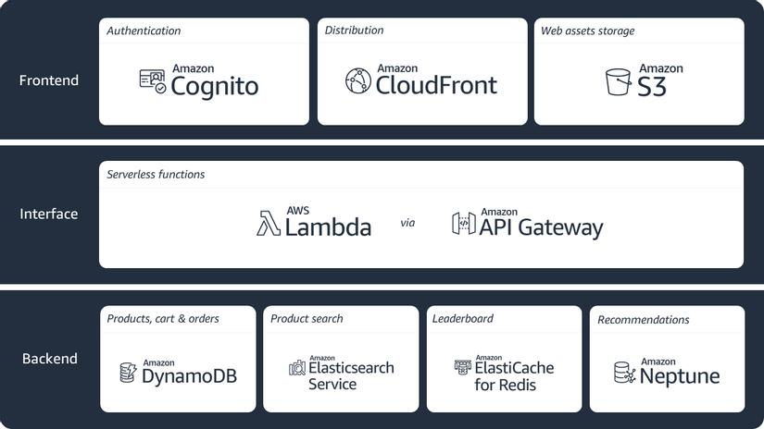

ARCHITECTURE AND WORKFLOW
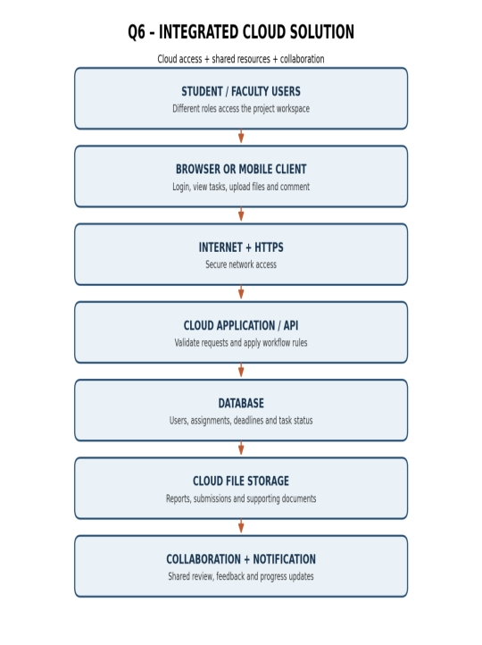
Figure 6: Integrated solution architecture showing how users access the application and collaborate through shared database and cloud storage resources.
How users access and collaborate
- The project leader signs in and creates a project workspace.
- The leader invites student members and the faculty guide.
- The leader creates tasks and assigns an owner and due date.
- A student opens the dashboard through a browser or mobile device.
- The student updates task status and uploads the related document.
- The faculty guide opens the shared report and adds feedback according to permission.
- The system stores the changes and displays updated progress to authorized users.
Data and permission design
Data / resource | Stored information | Access rule
User records | Account identity and role | Only authorized account administration can change role data.
Task records | Task title, owner, deadline and status | Team members view project tasks; assigned users update their tasks.
Project files | Reports, diagrams and supporting documents | Access follows project membership and assigned permissions.
Feedback | Faculty comments and review status | Students can read feedback; only authorized reviewers add it.
PROTOTYPE, TESTS AND EVALUATION
Prototype / mock-up plan
A simple prototype can be created using a shared Google Drive folder, a Google Sheet task tracker and a Google Doc project report. This demonstrates cloud access and collaboration without requiring a full software application. A more advanced prototype can use a web interface connected to a database and cloud file storage.
Two user test scenarios
Test | Action | Expected result | Actual result
Test 1 – Student member | Student signs in, opens an assigned task and changes its status from Pending to In Progress. | The new status is saved and visible to authorized team members. | Fill after practical test.
Test 2 – Faculty guide | Guide opens the shared report using Viewer or Commenter permission and provides feedback if allowed. | Guide can view the report and add comments only if the role permits. | Fill after practical test.

Limitations and improvements
- Limitation: Internet failure can prevent access or delay synchronization. Improvement: provide retry handling and supported offline access where possible.
- Limitation: Incorrect permissions may expose project data. Improvement: apply least privilege and review access regularly.
- Limitation: A basic prototype may not provide automated reminders. Improvement: add notifications for upcoming deadlines.
- Limitation: Storage and usage may be restricted by a service plan. Improvement: estimate capacity and cost before deployment.
Joint evaluation
Combining cloud access and collaboration improves efficiency because team members can access the same project information from different devices and update a common workspace. Shared files, comments and task status reduce repeated file exchanges and make progress easier to review.
Evidence to attach: prototype screenshots, shared folder permissions and completed records for both actual user tests. The actual result column must be filled after the tests are performed.

Q7 – DAY-4 DESIGN CHALLENGE: DESIGN A CLOUD-BASED COLLABORATIVE SOLUTION

INDEPENDENT PROPOSALS AND COMPARISON
This task must be completed collaboratively. Student A and Student B must first prepare separate proposals before discussing them. The original proposals should be retained as evidence. The group then compares the proposals, selects useful ideas and develops one joint design.
Stage 1 – Student A independent proposal
Proposed solution: Cloud-Based Student Assignment Coordination System. Problem: assignment instructions, files and deadlines are spread across messages and devices. Target users: students, faculty and team leaders. Access method: browser and mobile application. Required services: cloud storage, database, web application and identity management. Collaboration: shared folders, comments and task updates. Basic architecture: Student → Browser → Internet → Cloud Application → Database and File Storage.
Stage 1 – Student B independent proposal
Proposed solution: Cloud-Based College Event Coordination System. Problem: event teams need a shared location for schedules, volunteer duties and event files. Target users: event coordinators, volunteers and faculty. Access method: browser and mobile application. Required services: cloud database, file storage, web application and notifications. Collaboration: shared schedules, task assignments and comments. Basic architecture: Volunteer → Mobile App → Internet → Cloud Application → Database and Shared Files.
Stage 2 – Design comparison record
Comparison area | Student A proposal | Student B proposal
Main purpose | Academic assignment coordination. | College event coordination.
Target users | Students, faculty and team leaders. | Coordinators, volunteers and faculty.
Shared resources | Assignment files, deadlines and feedback. | Event schedules, volunteer lists and event files.
Collaboration | Shared documents, comments and task status. | Shared schedules, task assignment and comments.
Strength | Useful throughout the academic semester. | Useful for time-bound event planning.
Limitation | Requires accurate assignment and deadline updates. | Requires frequent schedule and volunteer updates.
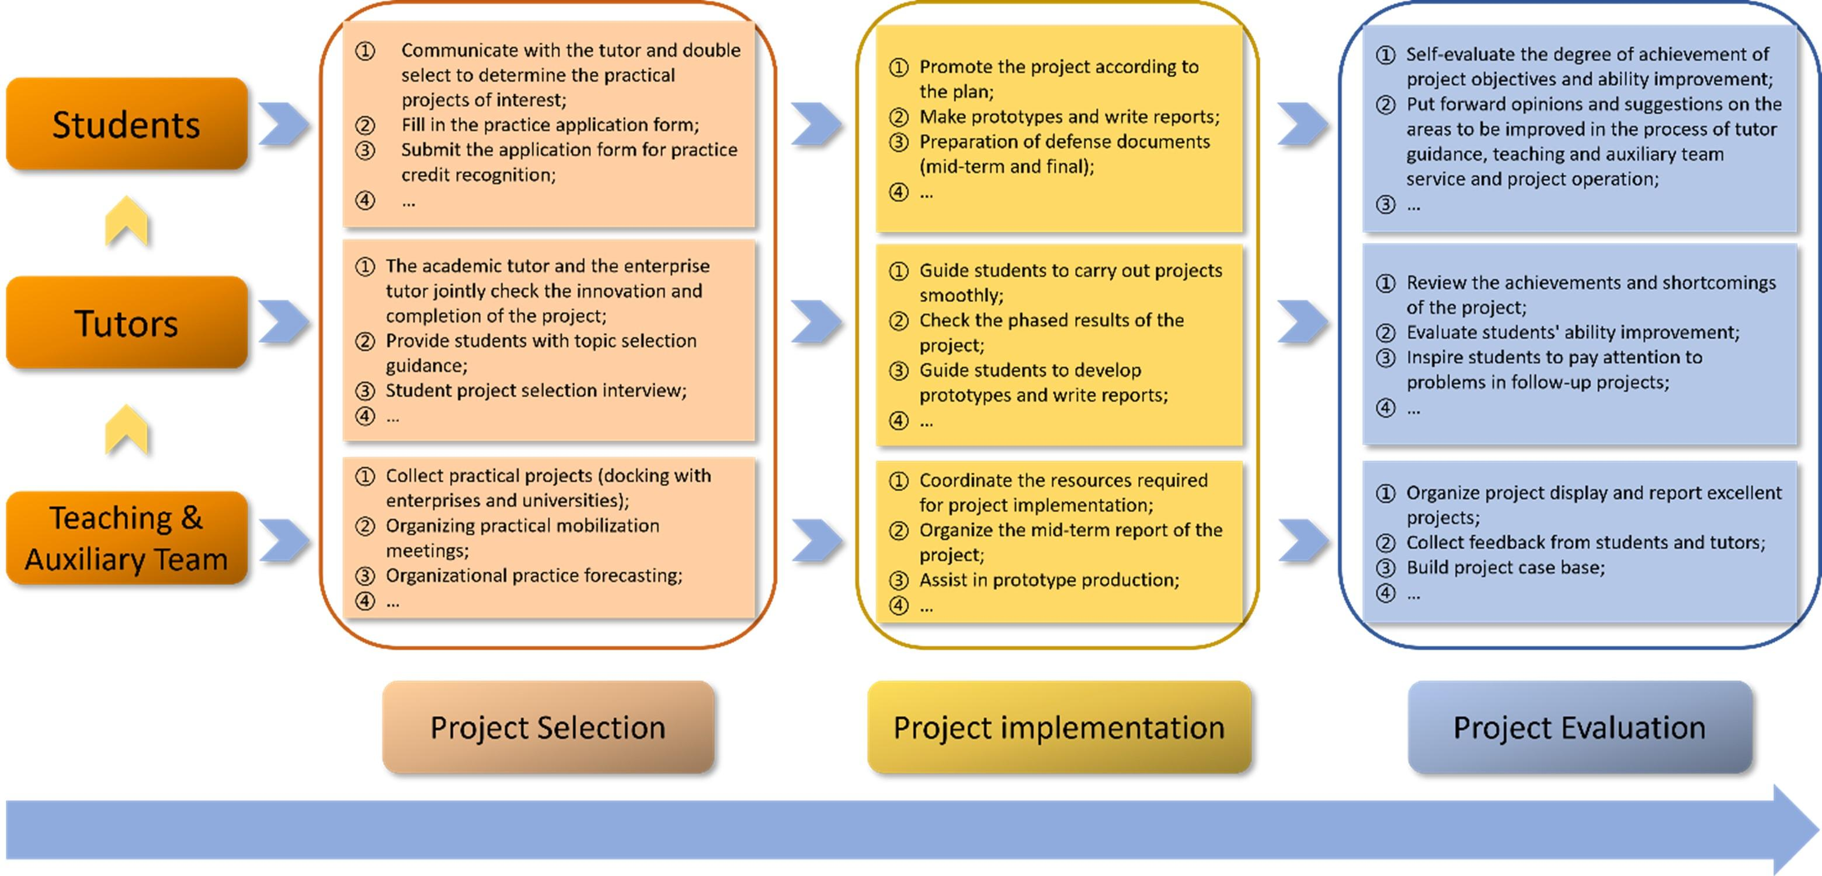
JOINT FINAL DESIGN AND ARCHITECTURE
Joint decision
The group selects the Student Assignment Coordination System because it supports regular academic work and can be tested using student and faculty roles. Useful ideas from the event proposal, such as task ownership and notifications, are included in the final design.
Stage 3 – Final solution specification
Design element | Joint final design
Problem | Assignment files, deadlines and feedback are spread across different channels.
Users | Students, faculty members and team leaders.
Cloud access method | Browser as the main method; mobile access for convenience; API for programmatic communication.
Network requirements | Internet connectivity and HTTPS/TLS for secure communication.
Cloud platform | Google Cloud or Microsoft Azure, selected according to cost, skills, security and service needs.
Web application / API | Login, assignment details, file upload, submission status and feedback.
Collaboration | Shared project folders, comments, task assignment and progress updates.
Authentication / security | Account verification, MFA where available, role-based permissions, encryption and backups.
Data/resource sharing | Students upload their own submissions; faculty review and comment; private submissions are not shared with unrelated students.

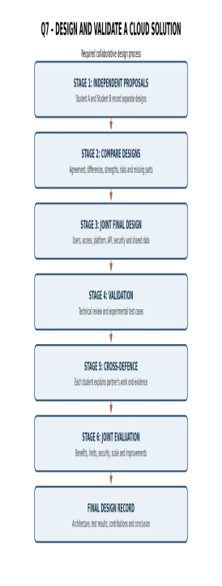
Figure 7: Required collaborative design process from separate proposals through comparison, final design, validation, cross-defence and evaluation.

VALIDATION, DEFENCE AND EVALUATION
Complete system workflow
Student or faculty user → Browser/mobile client → Internet using HTTPS → Cloud platform → Assignment web application/API → Authentication and role check → Database and cloud file storage → Shared workspace, submission status and feedback → Response displayed to the authorized user.
Stage 4 – Validation test cases
Test ID | Test condition | Expected behaviour | Observed result
T1 | Valid student account uploads an assignment. | File is stored and submission status is updated. | Fill after practical test.
T2 | Faculty opens a student's submission. | Faculty can view the file and provide feedback according to permission. | Fill after practical test.
T3 | Student attempts to open another student's private submission. | Access is denied unless permission has been granted. | Fill after practical test.
T4 | Network fails during upload. | Application reports failure or retry; incomplete upload is not marked successful. | Fill after practical test.

Student A – Technical validation
Student A explains the selected access method, platform services, architecture and API/web access. The design is suitable because browser access works across common operating systems, cloud storage holds shared files and role-based access separates student and faculty permissions.
Student B – Experimental validation
Student B prepares and runs test cases using at least two user roles. The student records actions, expected behaviour, actual observations and screenshots. Testing should include successful upload and faculty review, plus an access-denial test where possible.
Stage 5 – Cross-defence
Student A must explain what experimental evidence supports the design: successful login, file upload, status update, faculty review and permission testing. Student B must explain why the access and collaboration approach was selected: browser access supports different devices, cloud storage provides a shared location and role-based permissions control access.
Stage 6 – Joint evaluation
Evaluation factor | Assessment
Benefits | Remote access, shared files, faster feedback and fewer duplicate copies.
Access limitations | Internet dependency, provider downtime and device compatibility.
Collaboration benefits | Shared editing, comments, task ownership and visible progress.
Security risks | Account compromise, phishing, excessive permissions and data leakage.
Scalability | Cloud capacity can be increased according to user and storage demand, subject to cost and platform limits.
Improvements | MFA, backups, notifications, audit logs, accessibility and error handling.
Not appropriate when | Connectivity is unreliable, external hosting is prohibited or the provider cannot meet required compliance and control needs.

Final answer: Before selecting cloud-based access and collaboration, a designer should consider users, data sensitivity, devices, network reliability, cost, scalability, performance, security, authentication, permissions, backup, usability and legal or organizational requirements.

